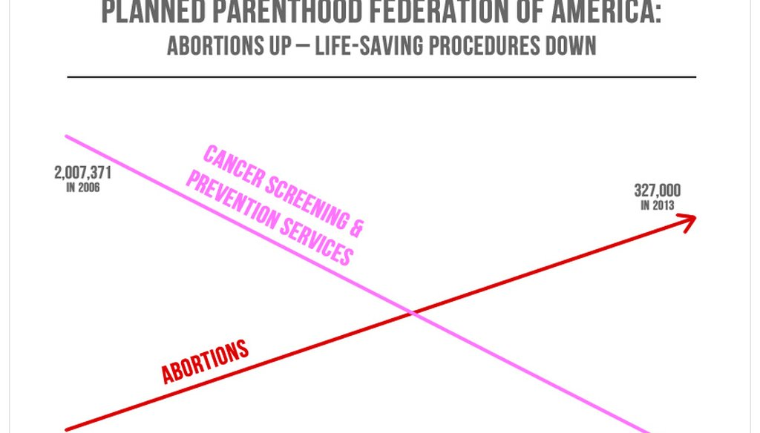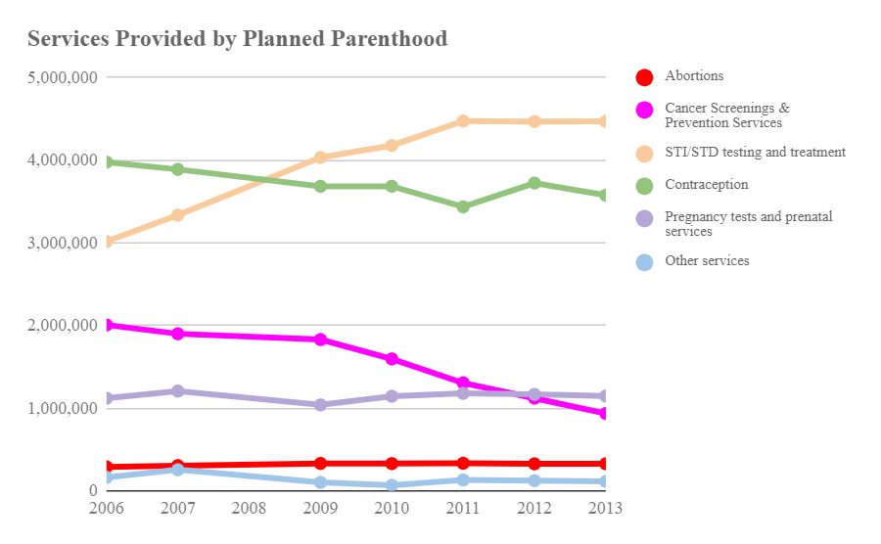

True Graphic

Improper Graphic

1. Both graphs can be found on: <https://www.datapine.com/blog/misleading-statistics-and-data/>  
2. The intended audience is the Planned Parenthood federation and the tax payers who should be concerned about its direction and activities. I know this because it was presented at a reform and oversight committee hearing.

Incorrect components:  
  1. The incorrect graph uses only 2 pieces of information: abortions to represent abortions but cancer screening to represent all other activities.  
  2. The visual implies that cancer screenings have fallen below abortions through the trend lines.  
Mechanism:  
  1. The visual hides other services offered by the planned parenthood federation (shown in correct graph)  
  2. The y-axis uses two scales and have been distorted in an inappropriate way to show abortion activities higher than cancer screenings which is incorrect when we read the actual numbers.  
How:  
The mechanisms were used to imply all other services (except abortion) have taken a hit because of the organization prioritizing abortions and mislead people against abortions.

1) Missing Components which can mislead:  
       - The lack of a Y-Axis.  
       - Placement of each series suggests that the inferred Y-Axis did not start from 0.  
  
2) a) Lack of a physical Y-Axis - This is equivalent to "Hiding Relevant Data to highlight what benefits us. Furthermore,  
          a secondary Y-Axis would have justified the slope of the Abortion series so that it cannot be misconstrued as on a  
          similar scale with the Cancer series. Unfortunately, in the context of the budget hearing, and to compare the actual shift  
          in spending between 2 services, both should be on the same scale.  
    b) Truncated Y-Axis (no zero based) - Using Graphic Forms in inappropriate ways (distorting data).  
  
3) a) In the absence of a Y-Axis, it leads the audience to assume that both series (Cancer and Abortion Services) lie on the  
         same Y-Axis. Hence spending priorities can not be properly correlated.   
    b) Having a non zero based Y-Axis allowed the Congressman to magnify or exaggerate the increase in Abortion services  
         spending from  289K in YR2006 to 327K in YR2013. Where in reality, in a span of 7 years, this is actually negligible change